

PHP Module Developers Guide

Tim Choate
May 3, 2004

Introduction
The name Bondware has multiple meanings. On one hand it implies software that brings people together via the internet. Today, the terms groupware, online community, collaborative software are commonly used to convey this same idea. On the other hand, Bondware is the glue that “bonds” many different web applications together into an integrated business system for the web.

Bondware/PHP represents the 3rd major evolution of the Bondware product line. The first two versions of Bondware were implemented in a proprietary application server called EASE. We refer to these versions collectively as Bondware/EZ. As the PHP language has progressed steadily over time into a robust, multi-platform, widely adopted language for web development, we have decided to port Bondware to the PHP language creating Bondware/PHP.

Bondware/PHP is a departure from Bondware/EZ and takes a minimalist approach to functionality including only the basic site configuration, some helpful abstractions, member management, content management, and add-on module management in the core product.

All other functionality is delegated to modules that can be easily developed in PHP by independent 3rd party developers. We are actively working to build a network of Bondware/PHP developers and we will support them by providing an online marketplace where Bondware customers can easily purchase their add-on modules. We anticipate paying monthly royalties to 3rd party developers based upon sales in the marketplace.

Architecture

Platform
Bondware/PHP will run on any platform that supports Apache, MySQL, and PHP 4.2+. The PHP installation must allow file write access to the site home directory. At the present time, Bondware/PHP has been tested on Windows, Linux, and Unix. With a little work, it should also run fine on Mac OS X but has not been tested on this platform.

MySQL does not have to reside on the same physical server as Apache/PHP and be redirected to another server with a simple change to Bondware’s config.php file. This provides the design flexibility to add a separate database server to scale site performance if needed.

Since Bondware/PHP sessions are serialized into the database, sessions can be shared transparently by multiple front-end servers if needed for scalability as a site grows.

Bondware/PHP is intended to be a light-weight framework into which existing PHP application can be quickly and easily integrated. This is desirable as our goal is to create value for end-users by providing a rich catalog of integrated business applications that can be easily purchased and applied to any Bondware/PHP site.

Module Anatomy

Directory Structure
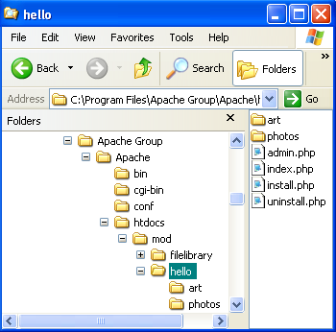
Figure 1 – Directory structure for Bondware modules.

The htdocs directory shown above is the DocumentRoot for Apache under Windows. The Bondware core scripts will always live in the DocumentRoot. Bondware modules will always be situated below the DocumentRoot in a subdirectory named ‘/mod’. This convention is the same in Windows, Linux, Unix. In Figure 1 above, this Bondware site has two modules loaded. The first module is named ‘filelibrary’. The second module is named ‘hello’ after the infamous helloworld application used to introduce almost every programming language. The hello module will be our method of introduce module development for Bondware/PHP.

The Bondware Module administrator function detects the presence of a module by traversing the file system under the ‘/mod’ directory. Placing standard files within a module’s directory will cause the Bondware Module administration to activate more options in its interface.

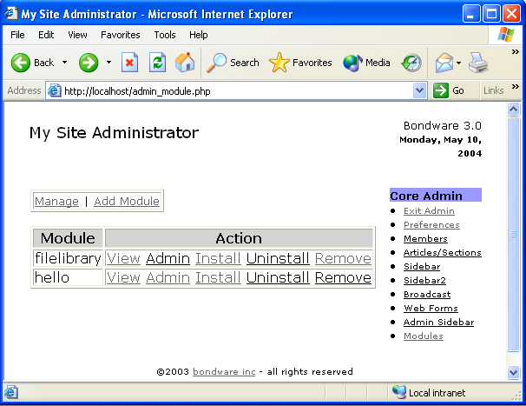
Figure 2 – Module administrator detects modules and standard files.

Standard Components

Module Names and Table Prefixes
A module name is the short (less than 12 characters) identifier associated with a module. It should be composed of all letters and numbers and should not contain spaces or other special characters. The module name is used as the directory name in the /mod directory. It is also used as a prefix on all tables created by the module (ie mod_sometable). In order to avoid developers creating modules with the same names, Bondware plans to establish a online form for developers to request the reservation of a module name. Until this process is automated, please email tim@bondware.com to reserve a module name.

index.php
As shown in Figure 1 above, the index.php file located within a module’s home directory implements the default user view of this module. When present, this script is linked to the “View” option in the Admin|Modules page. The example code below is taken from the “hello” module. The purpose of this very simple module is to demonstrate the basic components of a Bondware module and a bit about the Bondware API.

<?php

// index.php from 'hello' module

require '../../bw_core.php';
require '../../header.php';

$db->execute("select * from hello_target where name = 'hellotarget'");
echo "<BR><BR>Hello <B>{$db->result[0]['val']}</B>";

require '../../footer.php';

?>

The Bondware/PHP API is loaded by the ../../bw_core.php include above. The ../../header.php include outputs the standard header for all front-end pages on the site. Likewise, the ../../footer.php include outputs the standard footer for all front-end pages.
The module itself is a vast improvement on the legendary helloworld program. This version is configurable to allow the admin say hello to almost any audience. Note that it does a database lookup using the Bondware database abstraction class and says hello to the result of that query. Although authored with a tongue-in-cheek attitude, the basic structure demonstrated here will apply to all Bondware modules.

admin.php
The admin.php file located within a module’s home directory implements the admin interface for this module. When present, this script is linked to the “Admin” option in the Admin|Modules page.

<?php

// admin.php from 'hello' module

require '../../bw_core.php';
require '../../admin_header.php';

if (isset($_POST['htarget']))
{
$db->execute("UPDATE hello_target
SET val = '{$_POST['htarget']}'
WHERE name = 'hellotarget'");
}

echo "<form action=\"admin.php\" method=\"post\">";
echo "Hello Target: <input type=\"text\" name=\"htarget\">\n";
echo "<input type=\"hidden\" name=\"htarget_required\" value=\"Target is required\">\n";
echo "<input type=\"hidden\" name=\"htarget_encode_html\" value=\"Y\">\n";
echo "<input type=\"hidden\" name=\"htarget_max_10\" value=\"Target must be less than 10 chars\">\n";
echo "<input type=\"hidden\" name=\"htarget_regexp_error\" value=\"Target must be all letters\">\n";
echo "<input type=\"hidden\" name=\"htarget_regexp\" VALUE=\"^([A-Za-z_\.]*)$\">";
echo "<input type=\"submit\" value=\"Try It\">\n";
echo "</form>\n";

require '../../admin_footer.php';

?>

Note that this code also includes ../../bw_core.php. The ../../admin_header.php is similar to the header included in index.php but includes security to limit access to admins of the site.

This script implements a form for specifying the audience that the module will greet. Note the use of Cold-Fusion style hidden form variables to specify edits on the form. Once a valid audience is entered and submitted, the audience is updated in the database and will be reflected by the front-end view of the module. Amazing, no?

install.php
The main purpose of this standard module component is to create and initialize required database tables and setup front-end and admin sidebar links as needed. It is “included” by the core script ‘admin_module.php’ when a module is added. Note that it does not include ‘bw_core.php’ in the same manner as ‘index.php’ and ‘admin.php’ above. It also contains a guard to ensure it is included by the ‘admin_module.php’ script. This prevents someone from installing/uninstalling a module simply by calling the URL directly.

<?php

// install.php from 'hello' module

// ensure script is run from Module Admin
if (!strstr(FILE, 'admin_module.php'))
exit();
require 'bw_core_install.php';

$db->execute("CREATE TABLE hello_target (
name char(30) DEFAULT '' NOT NULL,
val varchar(255) DEFAULT '' NOT NULL,
PRIMARY KEY (name)
)");

$db->execute("insert into hello_target
set name = 'hellotarget',
val = 'world'");

echo 'Database tables created.<BR><BR>';

bw_AddSidebar("Extras","Hello",10,"/mod/hello");
bw_AddAdminSidebar("Extras","Hello Admin",10,"/mod/hello/admin.php");

echo 'Sidebar links added.';

?>

Note that this script also includes ../../bw_core_install.php that contains additional functions to assist in installing new modules such as bw_addSidebar() and bw_AddAdminSidebar().

uninstall.php
Likewise, the primary purpose of this script is to remove the database tables for this module. It is “included” by the core script ‘admin_module.php’ when a module is removed. Note that it does not include ‘bw_core.php’ in the same manner as ‘index.php’ and ‘admin.php’ above.

<?php

// uninstall.php from 'hello' module

// ensure script is run from Module Admin
if (!strstr(FILE, 'admin_module.php'))
exit();

$db->execute("DROP TABLE hello_target");

echo 'Database tables removed.';

?>

Note that this script only removes database tables. The actual module directory and all associated files are removed by the Admin Module manager as needed.

Sub-directories
All files uploaded/created by a module should be self-contained within the module’s home directory. We recommend the use of a ‘/art’ sub-directory for all the interface graphics used by a module. This will allow developers to deliver a basic module interface that can later be re-skinned by 3rd party graphic designers. This addresses the reality that most coders are not proficient graphic designers and vice versa.

Module Packaging and Installation
Packaging your newly developed Bondware module for distribution is easy by design. In Linux, just ‘cd’ to your module’s home directory and the type following command:

zip -r mymodule.zip *

In Windows, use a tool such as WinZip to create the same type of zip file.
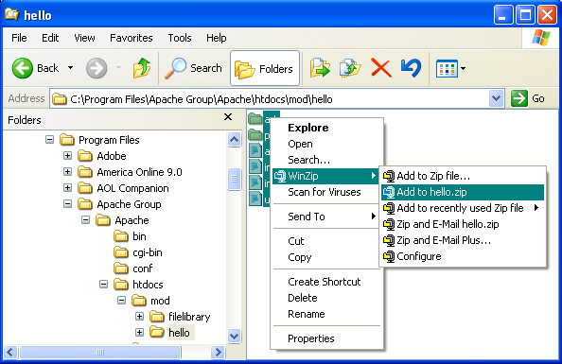
Figure 3 – Using WinZip in Windows to Package a Bondware Module

Note that the name you give your zip file should correspond to your assigned module name.

Now you can apply your module to any Bondware/PHP site using the Admin|Modules|Add Module feature. The zip file is uploaded to the site and expanded into the appropriate directory in the /mod directory. Once the module is added, you should go to Admin|Modules and click the ‘Install’ link on that module. You should now be ready to ‘View’ or use the module.

In the future, we anticipate that Bondware modules will be purchased from a online catalog. The install process will also be slightly more elaborate to ensure that developers are fairly compensated for their intellectual property. We are currently working out a method to allow a limited time free trials of a module prior to purchase.

Bondware Development Guide

Getting Started
The best way to learn the Bondware programming framework may well be to examine some of the code included in the core application. Many of the admin functions demonstrate advanced coding techniques using the bw_core API.

Important Constants

FILE
This is the path from the DocumentRoot to the current script (ie. /mod/hello/index.php).

FILE_DIR
This is the file system path to the directory where the currently executing script resides (ie. c:/program files/apache group/apache/htdocs/mod/hello/).

LOG_SQL
If defined as ‘true’, this will cause the database abstraction class to log & time all database queries. This can be useful to analyze performance issues on a live site.

Important Global Variables

$app
The Bondware core defines a class called bw_globals. $app is global variable and an instance of this class. It’s purpose to manage an array of application/configuration settings that are used at run-time. The assumption is that this data is primarily read-only so the data is read into memory at the beginning of script execution & only gets serialized back to the database when something is updated.
Any Bondware script can call $app->get(), $app->isbound(), and $app->update() functions to access information stored in this object.

$db
$db is a global variable created by bw_core and an instance of the bw_db class described below in the “Database Abstraction” section.

Form Processing
Bondware supports ColdFusion style form validations as shown below. Bondware’s form processing logic also forces PHP to behave as if the “magic_quotes_gpc” is enabled, even if it is not, to ensure consistency in form processing. This is handy for database applications, but may require you to call stripslashes() to process form values for some applications.

The following conventions are supported where fld1 is a form field that allows user input. Validations are automatically performed by bw_core.php.

1. <input type=hidden name="fld1_required" value="You must enter a value for fld1">

2. <input type=hidden name="fld1_max_20" value="Value of fld1 cannot exceed 20 chars">

3. <input type=hidden name="fld1_encode_html">

// If present, causes HTML characters to be converted to their special char equivalents
// via call to htmlentities() on the field value as part of processing.

4. <input type=hidden name="fld1_regexp" value="^[a-zA-Z0-9\_\.-]+@[a-zA-Z0-9\_\.-]+\.[a-zA-Z]+$">
<input type=hidden name="fld1_regexp_error" value="Please enter a valid email address">

Database Abstraction Class
Bondware’s database abstraction is implemented in bw_core by a class named bw_db. The ultimate purpose of this class is to enable Bondware to run equally well on any of the supported database engines. MySQL, postgres, and sqllite are currently supported however, the initial version of Bondware/PHP will only work with MySQL out of the box due to the use of non-standard SQL statements such as REPLACE in earlier versions of Bondware. We plan to remove these dependencies in subsequent releases of bw_core.

// Class for database connections
//
// The database connection occurs when the class is instantiated.
// Support is included for MySQL, PostgreSQL and SQLite.
// Sample code to open database, execute query and return results:

if (!$db = new bw_db('mysql','localhost','bwuser','bwpassword','bwdb'))
{
echo 'DB Connection Failed!';
exit;
}

if (!$db->execute('SELECT * FROM app_var'))
{
echo 'Query Failed!';
}

echo '<table>';
foreach ($db->result as $row)
{
echo '<tr>';
foreach ($row as $column)
{
echo '<td>' . $column . '</td>';
}
echo '</tr>';
}
echo '</table>';

Session Management
Bondware uses PHP 4.x Session Support to create its own session handler. Most importantly, Bondware sessions are stored in the database and are therefore can be shared transparently by multiple front-end servers behind a load-balancing switch. This may seem like overkill for Bondware running locally on a Windows box, but it becomes critical on high traffic sites and is already accounted for in the Bondware design.
The good news is that Bondware’s session management system should be largely transparent to 3rd party developers and the flexibility discussed above will be there when you need it.

Member Authentication
Bondware has a strong notion of site membership. Therefore considerable attention has been given to how members are authenticated and logged into the site. This happens automatically thru interaction between bw_core and Bondware’s security system. If you are have some free time, you might want to review the following scripts for details:

- bwcore.php
- authenticatelogin.php
- login.php
- secure.php
- AdminSecure.php

At login, Bondware offers the user the option to save their login info in a cookie. The password cookie is a md5 hash of the full password for obvious security reasons. Once planted, users should not have to login on each subsequent visit to a Bondware site.

Misc Functions

bw_encode($text)
Converts special characters to PHP’s htmlentities() equivalents. For example, ‘>’ will become ‘&gt;’.

bw_ParagraphFormat($text)
Formats stored text for HTML output. CRLF pairs in the text are converted to <BR> and blank lines are converted to <P> paragraph breaks.

bw_ExtractFileExt($filename)
Extracts the DOS style suffix from arbitrary file names. For example, bw_ExtractFileExt(“mysong.mp3”) would return “.mp3”.

bw_go($url)
Flushes the PHP output buffer and issues a HTTP “Location:” header to cause the browser to redirect to $url.

Programmer FAQ

How do I secure a script to members only or admins only?
Simply insert one of the include statements below at the appropriate point in your script:

// Restrict Access to Members
require '../../secure.php';

// Restrict Access to Site Admins
// Is called automatically by admin_header.php in admin.php example above
require '../../AdminSecure.php';

What is the best way to obtain member name/ user id?
There are two variables related to this in the framework:
$_SESSION['User']
$_SESSION['UserId']
They are initialized/set in authenticatelogin.php & bw_core.php
$_SESSION['User'] is either 'Visitor' or an actual username after authentication.
$_SESSION['UserId'] is either 0 or an actual userid (int) after
authentication.

How do I adopt the user specified site colors into my module?
Colors are stored in the $app global datastructure. You can review the color coding in admin_index.php (search for 'setColors'), but here's a quick summary of calls to return different color settings.
You can assume these are always initialized & always valid.

$app->get('bgcolor') // Background color
$app->get('text') // Text color
$app->get('link') // Link color
$app->get('vlink') // Visited link color
$app->get('color2') // Heading color (bg for section head in sidebar)
$app->get('color3') // Heading text color (fg for section head in sidebar)
$app->get('color1') // Navigational color (bg for non-link text in sidebar & hdr)
$app->get('color4') // Navigational color text (fg for non-link text in sidebar & hdr)

Apache/MySQL/PHP Installation Guide

Windows Installation

Step 1 – Setup the WAMP environment
The quickest way to set up Apache/MySQL/PHP environment on Windows is one of the WAMP installers. See the link below for one of the better installs from e-novative GmbH in Germany.

http://www.e-novative.de/en/software/wamp.php

Step 2 – Download the Bondware Module Developer’s Distribution
Download the ZIP file from www.bondware.com and extract into the Apache Document Root (usually C:\Program Files\Apache Group\Apache\htdocs. Bondware must be positioned at the webservers DocumentRoot to work properly. It will not run properly in a subdirectory off the DocumentRoot directory in this version.

Step 3 – Create and populate the Bondware database
Once downloaded and installed, you can access the included phpMyAdmin app at http://localhost/WAMP/phpMyAdmin. You will need to create an empty database (bondware) in which your copy of Bondware will run. Under the ‘SQL’ tab, you then need to run the ‘clean.sql’ script located in the Apache Document root (usually C:\Program Files\Apache Group\Apache\htdocs\clean.sql)
This will create the tables needed by Bondware.

Step 4 – Manually Edit config.php with your Settings
Update this file to reflect the name of the mysql database you created in Step 1. The default username/password for the e-novative WAMP mysql is e_novative/e_novative.

<?php

// Critical vars set on install

define('BW_DBTYPE', 'mysql');
define('BW_DBHOST', 'localhost');
define('BW_DBUSER', 'e_novative');
define('BW_DBPASSWORD', 'e_novative');
define('BW_DBNAME', 'bondware');
define('BW_URL','http://localhost/');

?>

Step 5 – Access the Site and Complete Admin Setup
Now you should be able to access your Bondware site at http://localhost. Login as admin/admin and click the admin link in the header to continue configuring your site.

Linux Installation
Installing the LAMP environment in Linux should be fairly easy for anyone experienced in Linux administration. Most modern Linux distributions ship with Apache/PHP 4.3 already loaded. The MySQL RPMs can be obtained at http://dev.mysql.com/downloads/ and are available for almost every platform imagineable. Due to some recent bad blood between the PHP and MySQL development teams, you may find that you have to do some tweaking to load the MySQL module in PHP, but the process is well documented and very doable.

Once you have the basic LAMP environment configured and tested, pick up at Step 2 under “Windows” above. The process will be essentially the same to get Bondware loaded and running.

